Technical Bulletin for Code Compliance [Template] – City Name | Date

9.33.3.1.(2) BCBC 2024 Overheating Protection Requirements

BCBC 2024 Overheating Protection Requirement
The BCBC 2024 includes new requirements for new residential buildings to be capable of preventing overheating inside each dwelling unit. This is referred to as Overheating Protection. The requirement applies to both Part 9 and Part 3 residential buildings. This bulletin provides information to facilitate building permit application, processing and approval.
BCBC 9.33.3.1.(2) Indoor Design Temperatures
At the outside summer design temperature, required cooling facilities shall be capable of maintaining an indoor air temperature of not more than 26°C in at least one living space in each dwelling unit.
BCBC 6.2.1.1.(2) Good Engineering Practice
Indoor design temperatures for residential buildings shall be those established in Article 9.33.3.1.

How This Requirement Applies
- Part 9 single family homes with a secondary suite count as two dwelling units, and this requirement applies to each unit.
- Part 9 multi-unit residential buildings must demonstrate compliance for each dwelling unit.
- Part 3 multi-unit residential buildings must comply following Good Engineering Practice (see page 3).
- Mechanical systems that provide cooling must be permanently installed and fixed to the building. Portable air conditioners and window-mounted units are not acceptable.
- A CSA F280 report for mechanical cooling sizing is required unless complying with Part 6. This report is either separate from or a subsection of the report showing compliance with 9.33.5.1. Capacity of Heating and Cooling Appliances.
- Documentation matching the requirements outlined in the following pages is required at building permit application.
- If there are any changes to the building design during construction which may impact mechanical system sizing, updated documentation, including updated CSA F280 calculations, will likely be required.

Overview of Compliance Pathways for Part 9 Residential Buildings
Figure 1 outlines the three basic compliance pathways. Refer to page 3 for further information on Part 3 buildings.
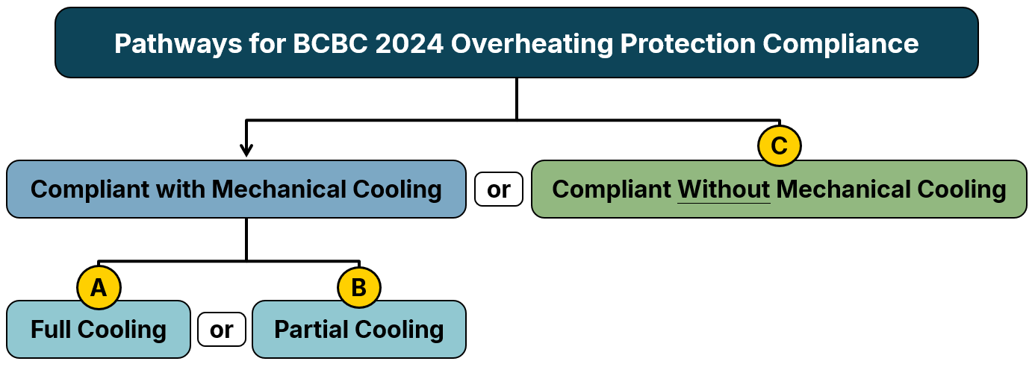
Figure 1: Compliance pathways for meeting Overheating Protection requirements.

A) Full Mechanical Cooling (No Additional Documentation Required)
The full mechanical cooling approach meets overheating protection requirements when each dwelling unit has mechanical cooling equipment that is integrated, permanently installed and sized for the space(s) it serves.
Requirements for Typical Compliance Using CSA F280
(for self-contained systems serving a single dwelling unit or a house with a secondary suite)
1. | Mechanical cooling sizing calculation prepared in accordance with CSA F280-12 Determining the Required Capacity of Residential Space Heating and Cooling Appliances. | ☐
2. | Calculation performed uses software or a tool verified by HVAC Designers of Canada. | ☐
3. | Indoor design temperature (cooling setpoint/overheating limit) is set to 26°C or lower. | ☐
4. | Outdoor design temperature is at least:  - The temperature set by local AHJ for the building location, or  - The 2.5% July dry-bulb temperature for the building location from Appendix C, Division B, BCBC | ☐
5. | Internal loads, including occupants, appliances, and lighting are included in accordance with CSA F280. | ☐
6. | Envelope performance inputs (U-values, SHGC, etc.) used in load calculations match permit drawings. | ☐
7. | A standard CSA F280 Calculation Summary Report is provided, showing at least the “Total Building Value” (100% load) is used for equipment sizing if the cooling setpoint is higher than 24°C. | ☐
8. | The proposed cooling equipment is identified and is shown to be capable of meeting the load. | ☐

B) Partial Mechanical Cooling (Additional Documentation Required)
The partial mechanical cooling approach meets overheating protection requirements when each dwelling unit has mechanical cooling equipment that is integrated and permanently installed and sized for the Cooling Zone area it serves.
Requirements for Cooling Zone Compliance Using CSA F280
(self-contained systems serving a single dwelling unit or a house with a secondary suite)
1. |  |  | The designated Cooling Zone is suitable for use by all the occupants in the dwelling unit: |  |  | ☐
 |  | a. |  |  | The Cooling Zone is a living space designed for occupancy and meets applicable accessibility requirements. | ☐
 |  | b. |  |  | The Cooling Zone only serves one dwelling unit and can accommodate all occupants for an extended period. | ☐
 |  | c. |  |  | For multi-unit buildings, the Cooling Zone in each dwelling unit is assessed separately to show compliance with the overheating protection requirements. | ☐
2. |  |  | Mechanical cooling sizing calculation is prepared in accordance with CSA F280-12 Determining the Required Capacity of Residential Space Heating and Cooling Appliances, with the following modifications to account for the design characteristics of the Cooling Zone per CSDSB Bulletin B25-03: Cooling of a Single Living Space in Dwelling Units for Part 9 Residential. |  |  | ☐
 | a. |  |  | Designed to separate the Cooling Zone from the remainder of the dwelling unit. |  | ☐
 | b. |  |  | Design temperature of adjacent indoor spaces reflects the lack of mechanical cooling in them. |  | ☐
 | c. |  |  | Occupant load accounts for all occupants, including the corresponding ventilation airflow rate. |  | ☐
 | d. |  |  | Heat gain from the enclosure and adjacent spaces is appropriately accounted for. |  | ☐
 | e. |  |  | Concentrated heat gain from lights, appliances, and plug loads is accounted for. |  | ☐
 | f. |  |  | Supplemental compliance reporting to record this information is provided. |  | ☐
3. |  |  | Calculation performed uses software or tool verified by HVAC Designers of Canada. |  |  | ☐
4. |  |  | Indoor design temperature (cooling setpoint/overheating limit) is set to 26°C or lower. |  |  | ☐
5. |  |  | Outdoor design temperature is at least:  - The temperature set by local AHJ for the building location, or  - The 2.5% July dry-bulb temperature for the building location from Appendix C, Division B, BCBC |  |  | ☐
6. |  |  | Envelope/adjacent assemblies’ performance inputs (U-values, SHGC, etc.) match permit drawings. |  |  | ☐
7. |  |  | A CSA F280 Calculation Summary Report is provided showing at least the 100% load cooling capacity is used for equipment sizing, regardless of cooling setpoint. |  |  | ☐
8. |  |  | The proposed cooling equipment is identified and is shown to be capable of meeting the load. |  |  | ☐

C) No Mechanical Cooling (Registered Professional Required)
The “passive only” Overheating Protection approach meets requirements when each dwelling unit (or designated area within each dwelling unit) is designed with measures to manage heat gain and allow means of cooling such that the indoor temperature can be maintained at or below 26°C without any mechanical cooling equipment. The submission must demonstrate that the indoor temperature of the building as designed following good engineering practice can be maintained at or below 26°C for the conditions modelled.
Requirements for Passive Only Overheating Protection Design Compliance
1. | Evaluation and reporting of the passive design as per good engineering practice by a Registered Professional, following Part 6, Division B of BCBC and other appropriate industry references. | ☐
2. | Evaluation uses appropriate hourly modelling tools, validated to ASHRAE 140, which can model exterior shading or use results from supplementary analytical programs. | ☐
3. | Evaluation follows modelling procedures as per the applicable version of the City of Vancouver Energy Modelling Guidelines (EMGs). | ☐
4. | Envelope/adjacent assemblies’ performance inputs (U-values, SHGC, etc.) match permit drawings. | ☐
5. | Evaluation does not include occupant-controlled cooling load reduction strategies, such as operable windows or shades. | ☐
6. | Outdoor design temperature is at least:  - The temperature set by local AHJ for the building location, or  - The 2.5% July dry-bulb temperature for the building location from Appendix C, Division B, BCBC | ☐
7. | A sealed report from a Registered Professional is provided. The Registered Professional is qualified and experienced with hourly energy modelling, building physics, thermal comfort assessment, and overheating analysis. The report includes appropriate engineering documentation including summary of inputs, assumptions, results, and a clear statement to indicate that the building/dwelling unit as designed and modelled can maintain maximum 26°C indoor temperature. | ☐
8. | The appropriate Letters of Assurance for professional design and commitment for field review are provided with the submission. | ☐

Compliance for A or B and Part 3 Buildings Per Part 6 (Registered Professional Required)
Requirements per “Good Engineering Practice” (Part 6)
1. | Evaluation and reporting of the cooling design as per good engineering practice by a Registered Professional, following Part 6, Division B of BCBC. | ☐
2. | A sealed report from a Registered Professional (e.g., Mechanical Engineer) is provided showing inputs, assumptions, and results to demonstrate the cooling equipment sizing is based on the applicable parameters outlined in the Pathway A or B checklists or specific to the Part 3 building. | ☐
3. | Appropriate assurance for professional design and commitment for field review are provided with the submission. | ☐

How To Use This Document
This bulletin has been developed to help Authorities Having Jurisdiction (AHJs) create a technical bulletin for their jurisdiction outlining compliance procedures for Overheating Protection. For more information on the overheating protection requirements and compliance considerations, refer to the industry guidance report Navigating 2024 BCBC Overheating Protection Requirements and related resources as outlined in the accompanying Policy Brief Template.
We trust that this bulletin template meets your current needs. Please contact the undersigned if you have any questions.
RDH Building Science Inc.  Rebecca Zarins | CDT  Technologist 2  rzarins@rdh.com | James Higgins | AScT  Associate, Senior Consultant  jhiggins@rdh.com | Neil Norris | M.A.Sc., P.Eng., CPHC  Principal, Specialist  nnorris@rdh.com

